1) Write an algorithm that describes how to make scrambled eggs, try to use control words, like IF, WHEN, UNTIL, WHILE, WAIT, AND, OR.

1. Gather all your ingredients needed which in includes eggs, butter, salt AND pepper.
2. Then you will need the necessary equipment’s such as a bowl, fork, spatula and a pan.
3. Crack the eggs into a bowl AND add salt and pepper.
4. Beat the eggs, salt and pepper together with a fork UNTIL it is blended.
5. Put the pan over on the stove AND add butter to the pan then WAIT till the butter to melt.
6. IF it is taking a while to melt the butter then increase the heat on the stove.
7. WHEN the butter has melted, pour the beaten egg into the pan then stir slowly with a spatula.

2) Is Idle (the Python language shell) an Interpreter or an Compiler or both? Explain your answer.

Idle could be an interpreter and a compiler as they both translate language into machine languages, however it is more of an interpreter as it executes each statement as it is read whereas a compiler saves the language into the format to be executed later.

3) Write a command in the Idle shell that says “Hello world”

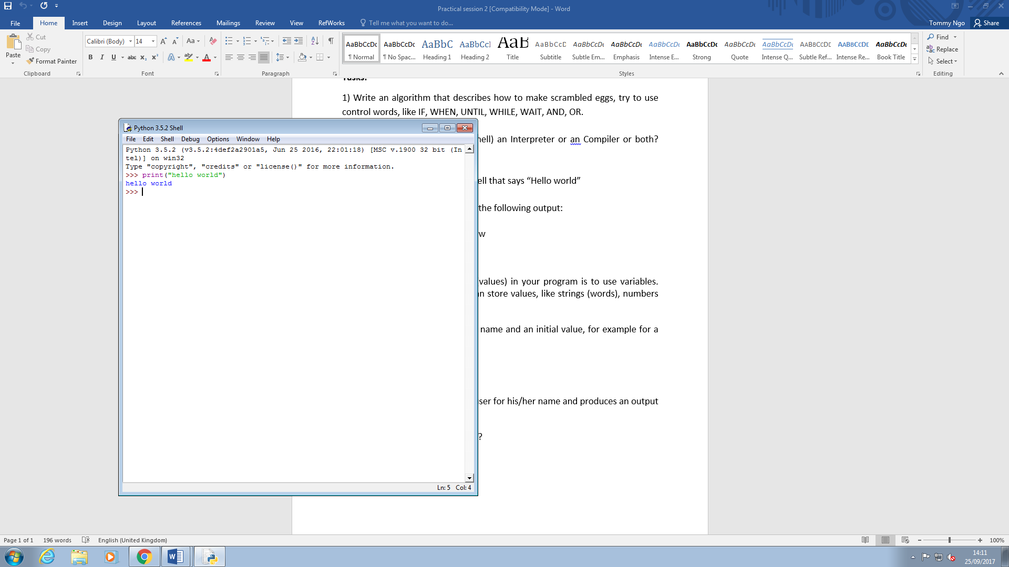

4) Write a program that produces the following output:

Hello World

I am in my ISD class right now

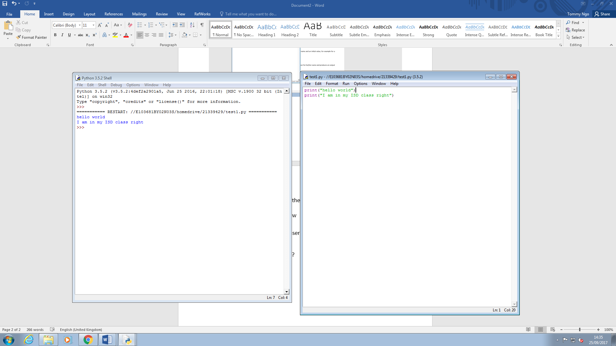

5) Write a program that asks the user for his/her name and produces an output like:

Hi there, what is your name?

>User input to be read<

Hello

“User name”

How are you?

